Clovis Capellan
Email: ccapellan@clovitech.com
Cell: 786-351-5807
https://www.linkedin.com/in/cloviscapellan
Senior Network Engineer | Network Security | Fortinet Certified

Senior Network Engineer with 15+ years of experience supporting enterprise and MSP environments, including multi-site network design, routing, switching, firewall administration, VPNs, SD-WAN, segmentation, high availability and incident troubleshooting. Strong production experience with Cisco, Cisco Meraki, UniFi and multi-vendor network environments. Fortinet-certified with hands-on laboratory experience configuring FortiGate, FortiManager, FortiAnalyzer and FortiSwitch solutions. Seeking a Fortinet-focused Network Security Engineer position that combines established networking expertise with expanding Fortinet specialization.

Core Skills
Fortinet: FortiGate, FortiSwitch, FortiManager
Security: SD-WAN, HA, IPS/IDS, SSL Inspection, VPNs, NAC, L2 Security, App Control, Web Filtering
Switching: VLANs, STP, MCLAG, DHCP Snooping, DAI, Port Security, LAG
Cloud: Azure, AWS, Route 53
Tools: Atera, NetBox, Entra ID, Intune, JAMF, Service Now, ConnectWise

Active Certs
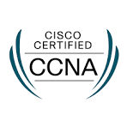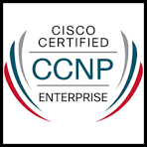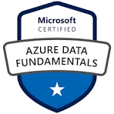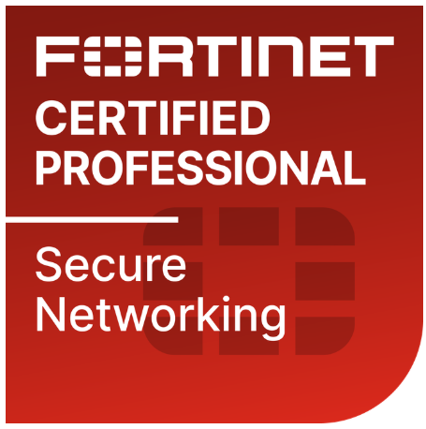
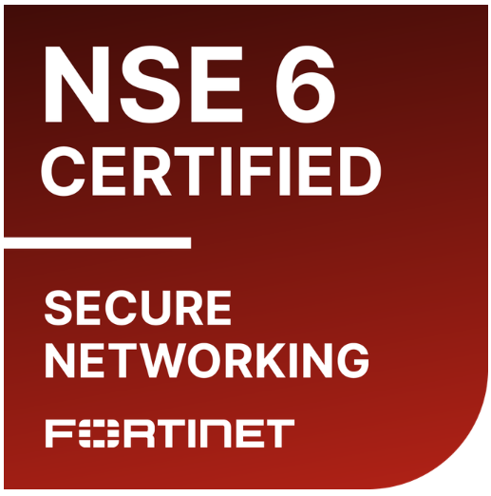

Fortinet Engineering Lab & Independent Projects

- Built a multi-device Fortinet lab using FortiGate and FortiSwitch to practice enterprise firewall and switching deployments.
- Configured firewall policies, NAT, DNAT, VLAN segmentation, IPsec VPNs, SD-WAN rules and routing scenarios.
- Implemented and tested web filtering, application control, IPS, SSL inspection and identity-based access using real UTM licenses on my pair of 60F and 80F.
- Practiced FortiGate HA configuration and controlled failover scenarios.
- Used FortiManager and FortiAnalyzer to practice centralized configuration, revision management, logging and security-event analysis.
- Configured FortiLink, VLAN trunking, LAG, MCLAG and Layer 2 protections including, DHCP snooping and Dynamic ARP Inspection.
- Configured Routing Protocols like BGP, OSPF, RIP on our Fortigate devices.
- Simulated cross-vendor routing and switching between Fortinet and Cisco equipment.
- Documented configurations, troubleshooting commands, test results and network diagrams.
- Configured a FortiGate multi-VDOM environment with inter-VDOM links, validating routing, network isolation, security-policy enforcement, and traffic flow across multiple VDOMs.
- Administered FortiManager ADOMs and deployed policy packages, VLAN and interface configurations, system templates, and centralized firmware upgrades across multiple lab devices.
- Designed and built a fully licensed, multi-vendor network lab featuring a Cisco router-on-a-stick and Catalyst switching infrastructure configured to simulate multiple WAN/ISP paths. Deployed four FortiGate firewalls in high-availability configurations, FortiSwitches using MC-LAG, and a FortiAP providing secured management wireless access.
- Deployed a FortiManager virtual appliance on a Windows Server 2022 Hyper-V host, enabling centralized configuration, policy, template, and firmware management across the Fortinet lab environment.

Work Experience

Vitality Senior Living
Network Security Engineer| Brentwood TN | June 2024 – Present

- Conducted a multi-site network security assessment covering firewalls, switches, wireless infrastructure, segmentation, monitoring and lifecycle risks.
- Designed and supported distributed network environments using Cisco Meraki and UniFi firewalls, switches and wireless infrastructure (Aruba, Unifi, Aerohive).
- Configured firewall policies, NAT, port forwarding, site-to-site VPNs, client VPNs, VLANs, traffic controls and redundant WAN connectivity.
- Served as the primary network escalation point for outages, VoIP, performance problems, DHCP exhaustion, ISP failures, vendor-managed infrastructure and more.
- Developed a Fortinet migration recommendation and proposed target architecture to improve security, standardization and centralized management across all our locations.
- Implemented proactive monitoring and alerting processes for WAN outages, switch failures and network-capacity problems.
- Created and maintained comprehensive network documentation for all locations, including device configurations, topology diagrams, IP addressing, VLANs, firewall configurations and infrastructure designs.
- Developed standardized operating procedures for common network issues, enabling the Help Desk to troubleshoot effectively, gather relevant information, and escalate incidents appropriately.
- Established and implemented standardized network configurations across all locations, including network segmentation, firewall policies, device configurations, and security controls.
- Automated biweekly firmware upgrades across all locations, improving patch consistency and ensuring alignment with network security standards.
- Led network deployments, ISP coordination, vendor escalations and infrastructure improvement projects across multiple locations.
- Manage VoIP infrastructure across all locations for multi PBX vendors like 8x8, Ring Central, Verve Cloud and more.
- Led all Network Transitions onboardings for new locations.

Softrim
IS Manager | Bonita Springs | Jan 2023 – June 2024
- Staff Management & Development: Lead and manage IT staff, providing coaching, setting clear job expectations, and going over professional growth.
- Policy & Procedure: Develop, implement, and oversee standardized policies and procedures for daily IT operations, ensuring efficient task delegation and workflow management for IT specialists.
- Vendor Collaboration: Work closely with third-party vendors to enhance and optimize the IT infrastructure.
- Client Support: Act as the primary point of contact for clients, providing comprehensive support for network infrastructure, laptops, mobile devices, security systems, and more.
- Microsoft Product Management: Oversee and manage Microsoft platforms such as Azure, Teams, SharePoint, Entra ID, Autopilot, Office 365, Intune, and others.
- Incident & Procurement Management: Handle service tickets and incidents while working with procurement to ensure timely purchase of IT equipment.
- Project Implementation: Lead and execute IT projects ensuring our team meets deadlines.
- CAB Member: Participate in the Change Advisory Board (CAB), providing input on upcoming infrastructure changes.
- Legacy System Management: Keep up with industry trends and changes, such as upcoming Windows 10 deprecation, firmware updates, and the replacement of legacy equipment.
- Stakeholder & Budgeting: Collaborate with stakeholders to align their IT needs with annual budgets, translating their vision into actionable IT implementations.
- Documentation Maintenance: Ensure all IT documentation related to hardware, software, and configurations is regularly updated and accurate.
- License & Contract Management: Oversee and manage license and contract agreements, ensuring compliance with company policies and procedures.
- Escalation & Policy Enforcement: Serve as the top-tier escalation point and enforce system policies across the organization.
Selected Projects & Achievements:
- Legacy Equipment Replacement: Geared towards the replacement of all upcoming legacy network and computer equipment.
- Cloud Migration: Successfully migrated on-premises servers to cloud service providers (CSPs) such as AWS and Azure.
- SharePoint Migration: Led the migration of over 200 sites from ShareFile and traditional shared file servers to SharePoint.
- Windows 11 Deployment: Managed the deployment of Windows 11 across all devices using Intune and automation tools.
- Vendor Contract Management: Negotiated and managed contracts with ISPs and third-party vendors, resulting in cost savings.
- Security Enhancement Projects: Led ongoing security initiatives using tools such as Mimecast, Upguard, KnowBe4, and others.
- Mobile Device Management (MDM): Configured and deployed MDM solutions including Ivanti, Intune, MobileIron, and JAMF.
- Client Transitions: Managed incoming and outgoing client transitions, ensuring hardware procurement within budget and seamless onboarding.
- Cisco Infrastructure Management: Installed, monitored, configured, and troubleshooted all Cisco devices with Meraki, ensuring licensing compliance and up-to-date firmware for firewalls, switches, routers, and access points.
- Technology Trend Monitoring: Continuously monitored Microsoft and industry trends to maintain a cutting-edge IT infrastructure.
- Cisco Device Deployment & Troubleshooting: Deployed and troubleshooted Cisco devices using Meraki, SolarWinds, and other tools, ensuring operational efficiency.
- Failover Implementation: Designed and implemented failover systems with regular after-hours testing based on industry best practices.
Herc Rentals
Network Engineer | Bonita Springs | Dec 2021 – Jan 2023

- Responsible for configuration, implementation, and support for network installations of Cisco devices such as: ISR, C111, 4331, 891, c2900 series, 9200, 9300 Catalyst, 6500, 3850s, 2960x, 2960s, 29xx Stacked, 4300, Cisco Firewalls 5500, Meraki APs and more.
- Worked with Protocols such as EIGRP, OSPF, DMVPN, S2S VPN, Remote VPN, Licensing, Failover testing and configuration, NHRP, BGP, NAT, DHCP, DNS and more.
- Design, configure, implement & Deploy Network Devices.
- Provide network support and troubleshooting network solutions for an enterprise network with several issues like packet loss, Jitter, delays.
- Work with customers, vendors, and technical teams to prospect and develop network design, installation, and support opportunities.
- Worked with several Application platforms such as: Solarwinds, Meraki Dashboard, Cyberark, ServiceNow and more.
- Provide engineering level support for incident and problem management.
- Create and maintain comprehensive documentation as it relates to network technologies, network topology, network equipment, and configurations.
- Document standards, methods and produce drawings of environments.
- Provide engineering support for problems identified within multiple systems or applications and will act as an escalation point for service desk, managed services

Softrim
Sr IT Specialist | Estero | Feb 2016 – Dec 2021

- Working with end users to solve issues remotely and on-site while delivering white glove service.
- Point of Escalation for mayor issues for our clients.
- Handle from start to finish ISP upgrades, firewall configuration and documentation.
- De-escalating issues.
- PC/iMac configuration & Troubleshooting.
- Network configuration & Troubleshooting with vendors like Cisco, Ubiquiti, HP, Dell, Meraki.
- Configure and monitor Backup Solutions like Veeam and ShadowProtect.
- Sonicwall installation, configuration and troubleshooting.
- Ubiquiti AP and Switches installation, support and troubleshooting.
- Installation of HP switches, Dell Switches troubleshooting.
- Experience with UniFi Controller, SSH command line configuration.
- Connectwise ticketing system.
- Experience with labtech and Automate.
- Experience configuring extensions, users and outside lines with VoIP like Coredial, 8x8, Allworx & Nextiva.
- Administration of: Microsoft Teams, SharePoint, Exchange Admin center, O365 Applications, Intune, Azure & AWS.
- Windows Server System Administrator, Hyper-V Installation, configuration and troubleshooting.
- Active Directory user creation and Group Policy deployment On-Prem and Intune.
- Print Server deployment, configuration and troubleshooting.
- Experience with Citrix XenApp, VDI, Citrix Studio & Citrix ShareFile.
- Experience with Citrix Policies, Citrix Director, XenCenter.
- Experience with Eldermark, Vitals, Yardi, TabulaPro, DSSI, Wellsky, Paychex.
- Experience with Office365 application installation, troubleshooting and deployment.
- Help Deployment and troubleshooting of O365 products like: OneNote, OneDrive, Outlook, Excel, Word.
- Experience with cloud providers Network, Storage accounts, migrations, VMs, Failover and Data Replication for Azure & AWS.
- Experience with Zoom, GoToMeeting, Bomgar, Screen Connect, TeamViewer.
- On-site visits to troubleshoot Networking issues, install of UPS, Battery Backups, PCs, Laptops,
- Phones, APs, Switches, Firewalls, Servers, transition experience and more.
- Symantec Management Deployment and configuration, SentinelOne, Capture Client.
- Experience with Microsoft Dynamics and SQL Database user creation and troubleshooting.
- POS Epson Printer receipt installation and troubleshooting
- Experience configuring scan to email, scan to folder, address book, DNS and more on the following MFPs: Ricoh, Lanier, Toshiba, HP, Xerox printers and more.

Entech
Network Engineer | October 2014 – January 2016

- Configuring, monitoring and troubleshooting Firewalls, Switches, Access Points, Servers.
- Manage the day to day networking troubleshooting of network.
- Onsite installation of network equipment.
- Administrate O365 Admin Center, Exchange Admin Center.
- Work with tools like Connectwise and Automate.
- Vendors: Cisco, Ubiquiti, Palo Alto, Fortinet, Sonicwalls, Dell, HP.
- Assist the Service desk with on-call issues with networking.
- Help troubleshooting issues with Office Applications, Outlook, Excel, Word, Power Point etc...
- Deliver Excellent customer service to clients.

Telefonica
NOC Engineer + Team Leader | August 2011 – September 2014

- Oversee the daily operations of the Network Operations Center.
- Manage Staff and hire engineers.
- Monitor and maintain network equipment which include Cisco Firewalls, Switches, Routers and other vendors.
- Respond to incidents and outages on a timely manner.
- Develop and implement NOC processes and procedures.
- Collaborate with other departments to triage technical issues.
- Ensure all incidents are logged, tracked, and resolved in a timely manner.
- Ensure all documentation is kept up to date on networking devices.
- Ensure all clients are notified on upcoming Maintenance Windows for upgrade firmware or replacement/upgrade of networking equipment.
- Provide detailed documentation of performance and incidents, conduct root cause analysis and timely communication to stakeholders.
- Provide Customer Service, maintain the clients inform with periodic updates of ongoing escalations within the company or from local providers.
- Proactively monitor and support over 200 international MPLS/VPN circuits, supporting nearly 80K end-users worldwide.
- Troubleshoot issues with BGP, EIGRP, OSPF, STP, VTP, VLANs, ACL, Port Security, Overutilization, CRC Errors, Port Channels, review configuration and escalate accordingly.
- Dispatch technicians onsite and help troubleshoot issues.
- Working with SLAs to make sure we meet the clients standards.
- Generate reports on network performance & incident trends. Analyze data to identify potential areas for improvement.
- Follow ITIL Procedures + got certified.
- Participate in the on-call rotation as needed.

Fortinet Lab Environment (Current Project)

• Built a FortiGate and FortiSwitch lab to simulate multi-site deployments
• Configured Web Filter, App Control, IPS/IDS, SSL Inspection and more.
• Tested VLAN segmentation, trunking, native VLAN behavior, and FortiLink integration
• Validated Layer 2 security features including DHCP snooping, 802.1X, DAI, IPGS and NAC
• Simulated router-on-a-stick integration with Cisco for cross-vendor interoperability

Contact Info
ccapellan@clovitech.com
786-351-5807 | LinkedIn

